General Welfare Requirement: Safeguarding and Promoting Children's Welfare
The provider must take necessary steps to safeguard and promote the welfare of children.
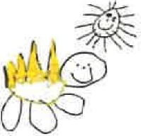
Gorran Pre School

Safeguarding children
1.8 Supervision of children on outings and visits

Policy statement
Children benefit from being taken out of the setting to go on visits or trips to local parks or other suitable venues for activities which enhance their learning experiences. Staff at Gorran Pre-School Hoglets ensure that there are procedures to keep children safe on outings; all staff and volunteers are aware of and follow the procedures below.

EYFS key themes and commitments
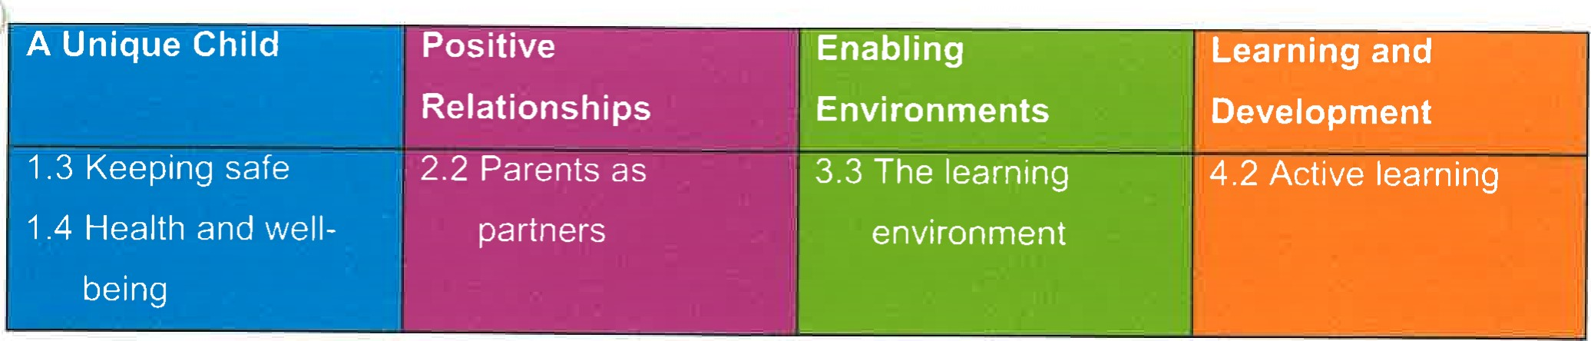

Procedures
- Parents sign a general consent on registration for their children to be taken out as a part of the daily activities of the setting.
- This general consent details the venues used for daily activities.
- There is a risk assessment for each venue carried out, which is reviewed regularly.
- Parents are always asked to sign specific consent forms before major outings.
A risk assessment is carried out before an outing takes place.
- All venue risk assessments are made available for parents to see.
- Our adult to child ratio is high, normally one adult to two children, depending on their age, sensibility and type of venue as well as how it is to be reached.
- Named children are assigned to individual staff to ensure each child is individually supervised, to ensure no child goes astray, and that there is no unauthorised access to children.
- Outings are recorded in an outings record book kept in the setting stating:
The date and time of outing.
The venue and mode of transport.
Names of staff assigned to named children. Time of return.
- Staff take a mobile phone on outings, and supplies of tissues, wipes, pants etc as well as a mini first aid pack, snacks and water. The amount of equipment will vary and be consistent with the venue and the number of children as well as how long they will be out for. Staff take a list of children with them with contact numbers of parents/carers.
- Records are kept of the vehicles used to transport children, with named drivers and appropriate insurance cover.
A minimum of two staff should accompany children on outings and a minimum of two should remain behind with the rest of the children.
- If the Gorran School minibus is used for an outing, the staff will perform all the school minibus checks on the morning of the outing before the children arrive.
- At least one member of preschool staff will have passed the mini bus driving test before using the school minibus.

Other useful Pre-school Learning Alliance publications

Register and Outings Record (2006)

Managing Risk (2009)
This policy was adopted at a meeting of: Gorran Preschool

Held on: October 2019
Date to be reviewed: October 2020
Name of signatory
Role of signatory (Manager)

Michelle Beard

Michelle Beard Pre-School Leader/Nominated Person

